**Importing Data Graphically:**

1. Go to Object Explorer and select the target database. Expand the Databases folder. Select the database and right click > Task > import flat file.

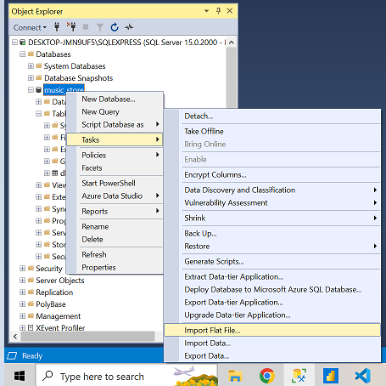

1. You will land on introduction page > click next

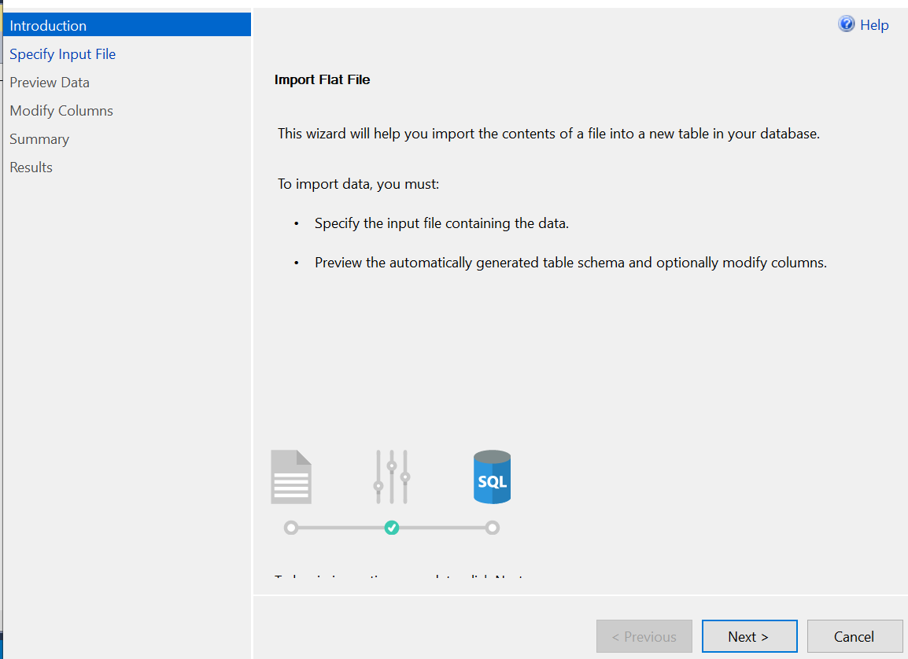

1. Select the file path by clicking on Browser

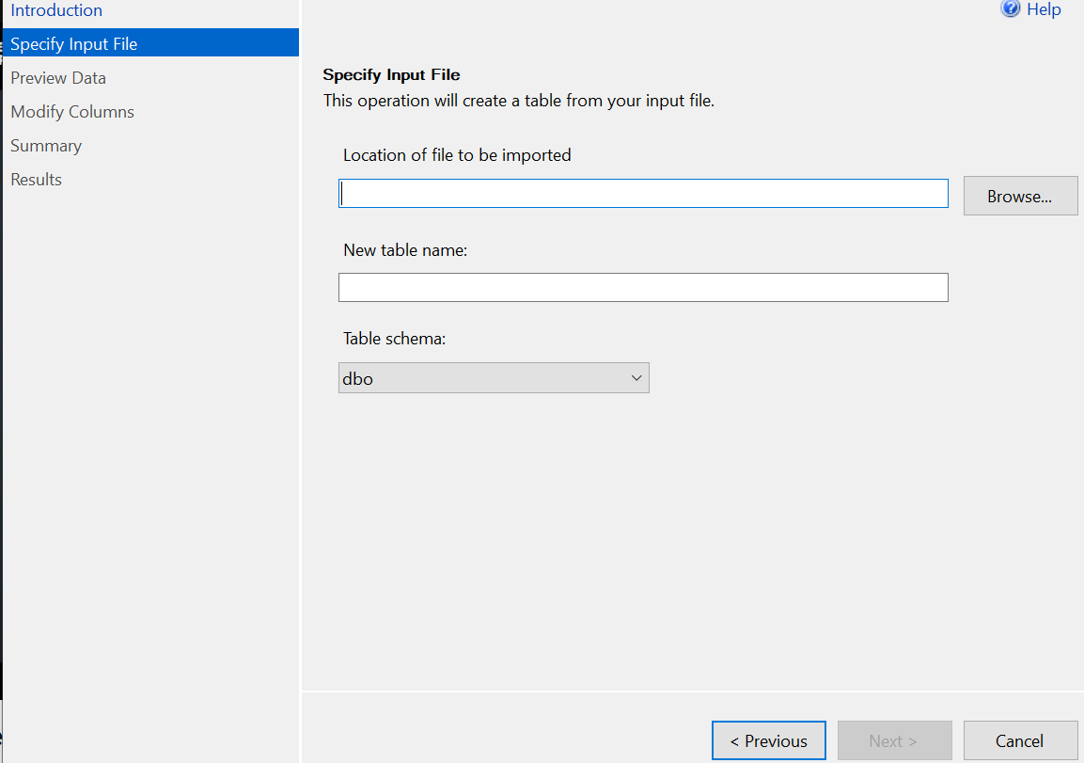

1. Select the target file and click on open

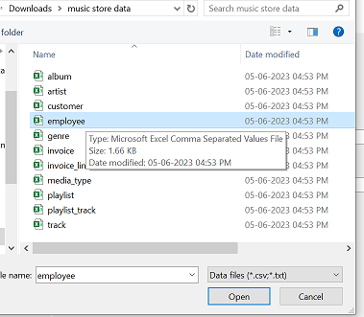

1. Click on Next

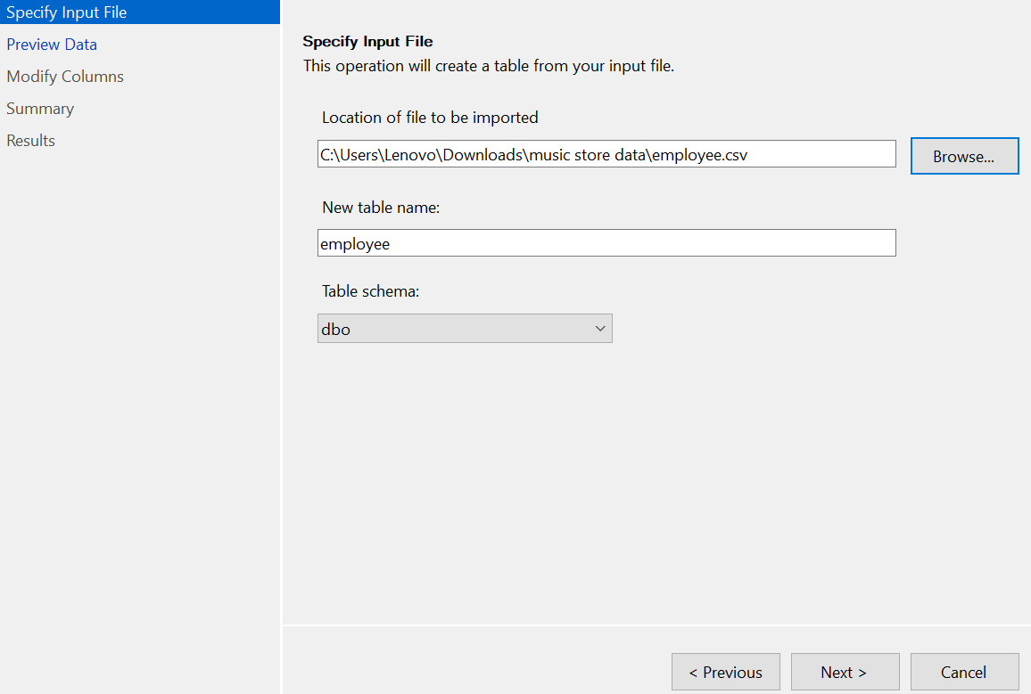

1. Data review page click on Next

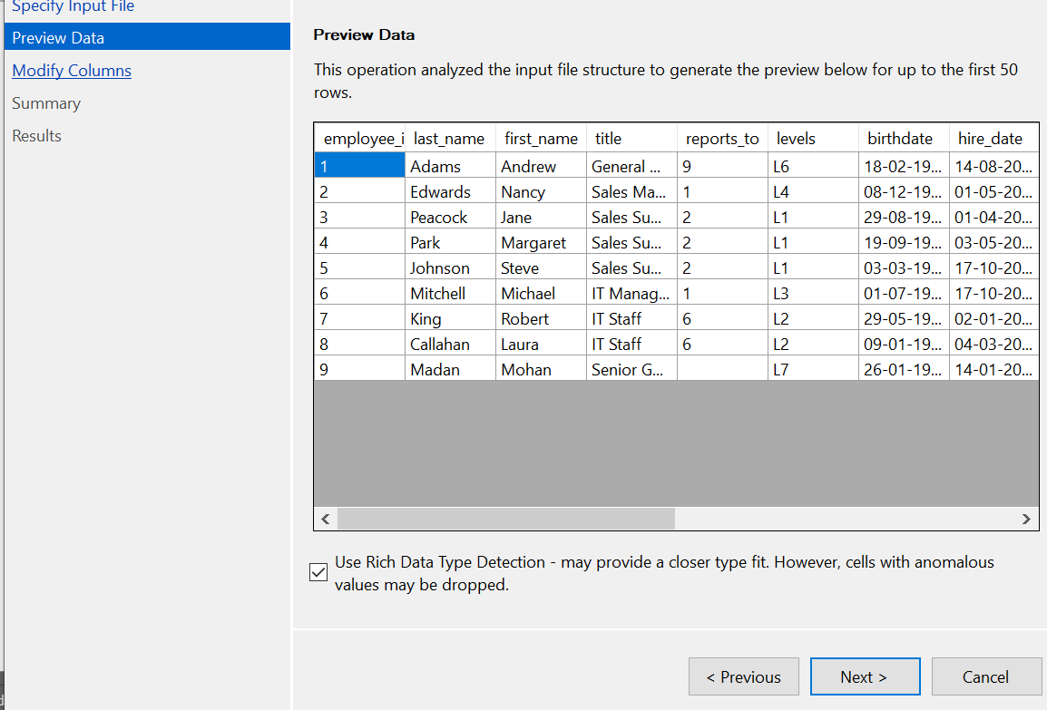

1. Modify column page make change if required and click next

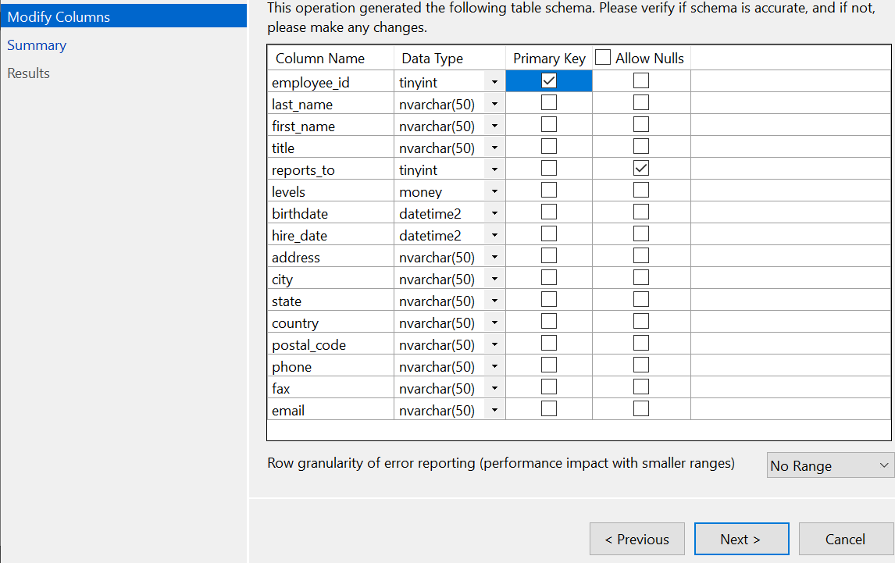

1. In summary click Finish

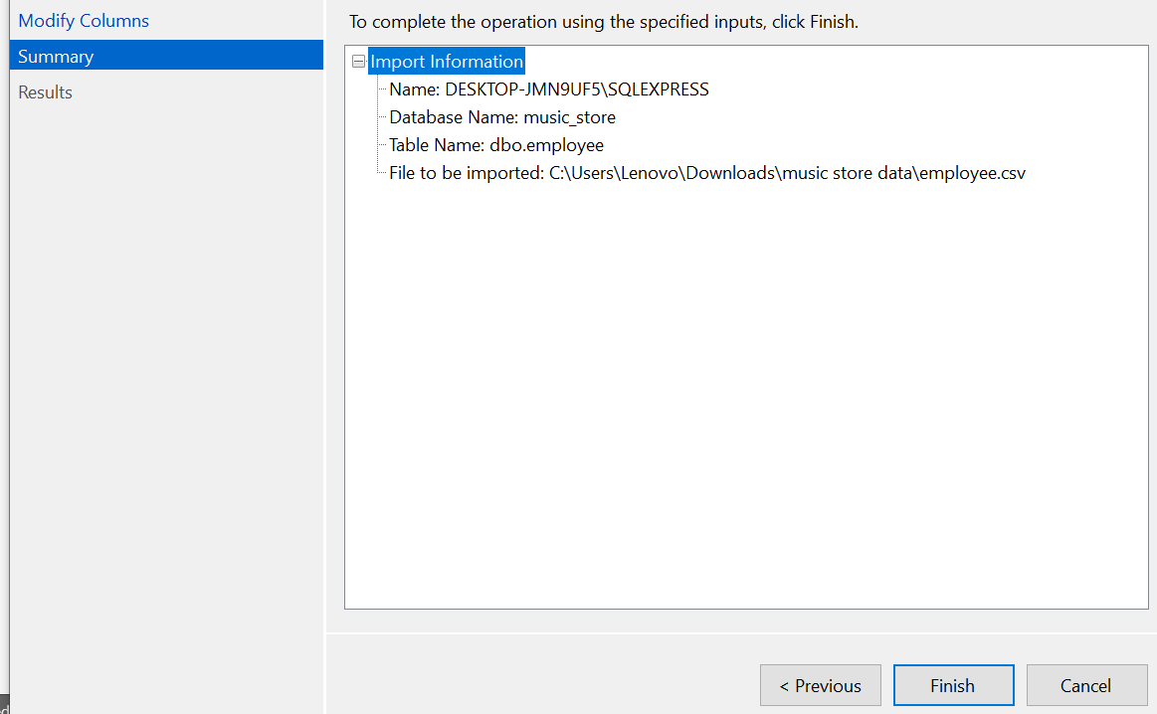

1. In result page click close

